If you watched the professional sports gambler James Holzhauer rampage on *Jeopardy!* last year―and have kept watching the show in this new season―you may have noticed something. Contestants are diving for big-money clues a lot sooner than in the past, sometimes right away.

It’s not just your imagination.

**James picked high-valued clues first. Now other players are too.**

In the first round of game play (the “Jeopardy Round”), the returning champion gets to select which clue is read. Below is a bar chart representing the values of clues that were selected first, from games beginning in the 2010-2011 season up to the game before James’ debut.

[Note on the data: the 2013-2014 season included a “Battle of the Decades” tournament where past champions like Chuck Forrest, Brad Rutter, and Ken Jennings were invited back to play against each other; similarly, early 2019 had an “All-Star” series where past champions competed in teams. Records from both of those tournaments have been removed for this analysis, as were the exhibition games that Jennings and Rutter [played against IBM’s supercomputer Watson](https://www.youtube.com/watch?v=P18EdAKuC1U) in early 2011.]

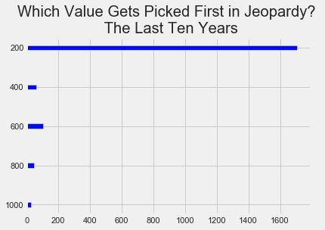

A clue from the top row is overwhelmingly popular, accounting for 87.6% of first picks. $1,000 clues, on the other hand, were only chosen first 28 times over that ten year period.

As Michael Dupée, winner of the 1996 Jeopardy! Tournament of Champions, [once explained](https://www.amazon.com/How-Get-Jeopardy-Win-Information/dp/0806519916), “The *Jeopardy!* folks want you to pick the questions in each category from the top to the bottom. This makes it easier to follow the questions with the camera and makes the board look better as they remove the used questions.” (Ken Jennings once wrote that, decades later, they’re [still recommending this](https://slate.com/culture/2014/02/ken-jennings-on-jeopardy-champion-arthur-chu-and-daily-double-hunting.html) type of play.)

Many contestants also found it easier to generate a rhythm this way―orienting themselves to the topic, and often eliminating possible options for higher-valued clues by noting their appearance earlier in the category. So if a “US Presidents” category mentions George H.W. Bush in one clue, then you can feel pretty safe that a later clue asking about Presidents with WWII military service would be looking for Eisenhower, Kennedy, LBJ―not Bush a second time.

There’s a logic to how that kind of play would make the game easier for you to follow. It would also make it easier for your competition to follow. Which is why it’s this kind of strategy that James Holzhauer rejected to break records and (even more exceptional for a *Jeopardy!* player) make headlines. Here are first round, first-pick selections from James’ 33 games last spring:

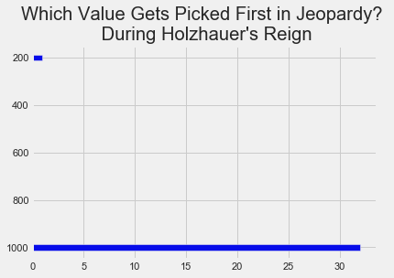

That lone $200 clue is from James’ first game, when the returning champion played by the book and lost to James by $23,680. Otherwise, James immediately selected a $1,000 clue 32 times―more times than they had been picked first over the last ten years of the game combined.

If you’re familiar with the show, you probably know what James was up to. James not only cleared the top-dollar clues off the board before his challengers could get a feel for the game or any momentum, he also built up a bankroll so that when he found Daily Doubles he would have the capacity to [wager tens of thousands of dollars](https://fivethirtyeight.com/features/the-man-who-solved-jeopardy/) and secure an insurmountable lead.

And since James left the show? This bar graph represents first picks this current season [note on the data: excluding Tournament of Champions games, which featured, among other things, a returning Holzhauer; this data goes up to and includes the game of Wednesday, April 29]:

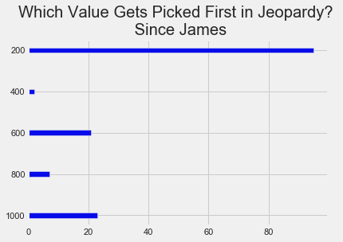

There’s still a preference for old-school, genial play that works down the board category by category―but there’s a clear alternate strategy for returning champions who want to clear the board of big money fast.

This was generally expected. A Fivethirtyeight article from James’ initial run dubbed him “[The Man Who Solved ‘Jeopardy!’](https://fivethirtyeight.com/features/the-man-who-solved-jeopardy/)” There [Oliver Roeder](https://fivethirtyeight.com/features/the-man-who-solved-jeopardy/) wrote, “perhaps Holzhauer’s success is the natural evolutionary destination of the show — a final, full realization of the strategic potential locked within its giant board.”

Other outlets had similar expectations. “[T]he Holzhauer effect will revolutionize the game” [predicted the *New York Times* in May of last year](https://www.nytimes.com/2020/05/02/opinion/sunday/coronavirus-prediction-laurie-garrett.html), while Holzhauer’s victorious games were still being aired ([Jeopardy tapes six to eight weeks in advance](https://www.post-gazette.com/ae/tv-radio/2020/04/22/The-Voice-NBC-John-Legend-COVID-19-American-Idol-KDKA-CBSN-Pittsburgh-Homeland-Showtime-Jeopardy/stories/202004220007), so James had [already lost when his run first began airing](https://fivethirtyeight.com/features/james-holzhauer-broke-jeopardy-but-is-broken-so-bad/)), “until another innovation comes along.”

The pronounced effect on gameplay remains clearly visible in the second clue selection of the Jeopardy Round. Here, again, we can see the difference from the pre-James era, James’ run, and the games this current season:

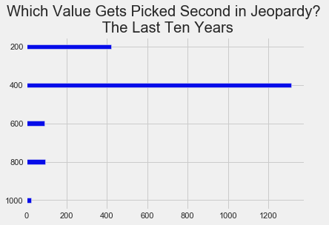

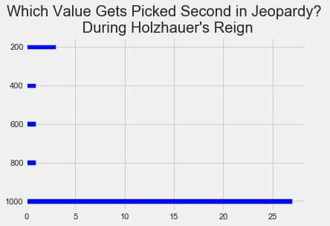

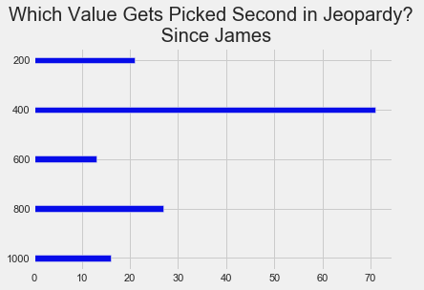

Once again, pre-James play is almost exclusively focused on working down to the board’s next clue (67.4%) or else starting a new category from the top (21.7%). James’ play targets the biggest money possible, and play since James suggests sizable proportions of contestants playing each strategy. In fact, clues in both of the top two rows now account for fewer second-choice picks (66.2%) than second row clues used to―testifying both to the deep rut of the old strategy and to the subsequent break-up of that old order of things.

In retrospect, though, looking at early clue selection in the second round of play (the “Double Jeopardy Round,” where the dollar values of clues are doubled) is even more interesting. Going into the Double Jeopardy Round, the first selection is made not by the returning champion, but by the contestant whose score is currently lowest. (A position James was never in―though in his second game he came perilously close.)

Previous to James’ arrival, the popular strategy was much the same: work down the board.

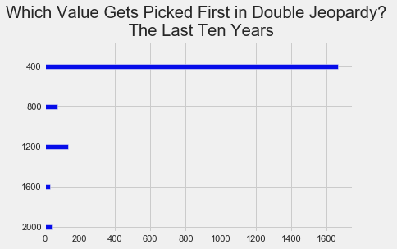

And once again, in games from this current season, we see people more ready to explore the board sooner:

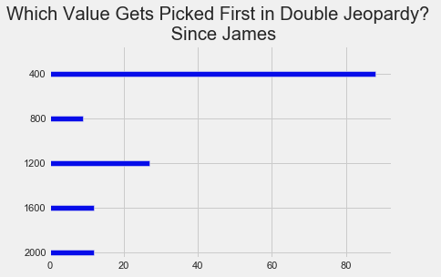

But that pales compared to the games played by people when they were going against James personally:

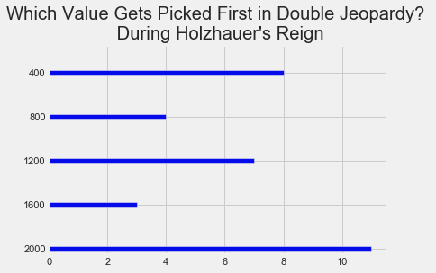

A plurality of clues selected were valued at $2,000―and all of those selections were made by people not named “James Holzhauer.” This suggests that however deep an imprint James left on the psyches of aspiring *Jeopardy!* contestants, it’s nothing compared to the effect he can have on someone in the same room. Future contestants may acknowledge that James’ strategy is superior, but nothing makes that more urgent than facing off against him and watching it dominate that game.

[Oliver Roeder noted](https://fivethirtyeight.com/features/james-holzhauer-broke-jeopardy-but-is-broken-so-bad/) this mimicry at the time in vivid language: “Holzhauer was such an [effective and alien](https://fivethirtyeight.com/features/the-battle-for-jeopardy-supremacy/) force that opponents began to mimic his style out of desperation, like growling at a hungry lion in hopes of scaring it away.”

**James methodically cleared the board of money as fast as possible; recent contestants have taken note.**

We can even watch this emulation take place over the course of an entire round, looking at plots of clue value over selection order. Suppose the *Jeopardy!* folks from earlier got their wish, and every category was cleared off the board in order, from top row to bottom. That would look like this:

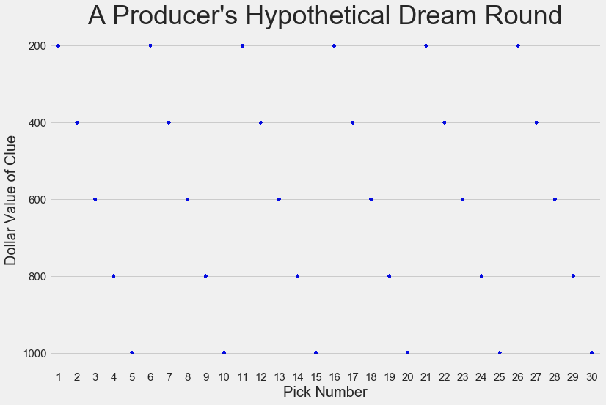

If we graph the real data from the games of the five years prior to James [note on the data: we use only five years of data for this graph because shading all ten years darkens the plot too much to see variation), we can get an idea what a typical Jeopardy Round looks like by seeing where pale dots are clustered and darkest:

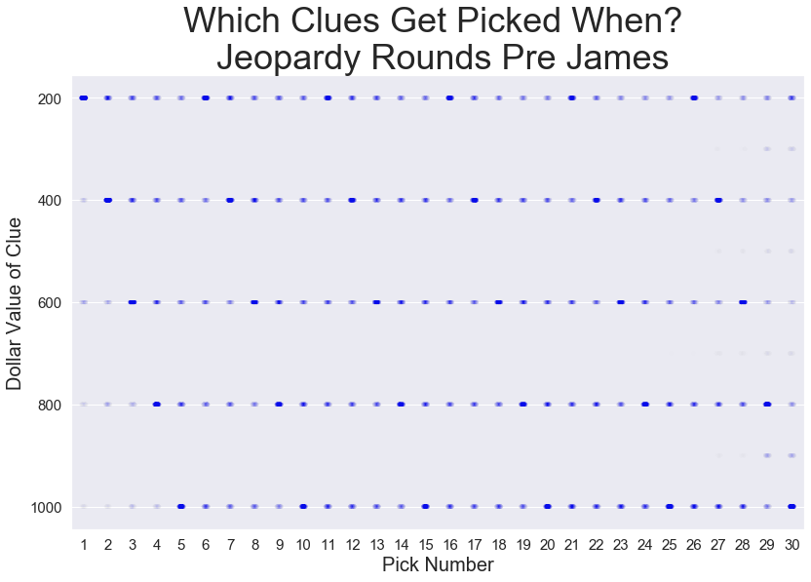

There’s some variety, but you can still make out the sloping diagonal lines where contestants process category after category, especially at the beginning and end where they concentrate on lower or higher valued clues.

[Note on the data: the faint dots in between real clue values represent interpolated data. Basically, since *Jeopardy!* is a half-hour of syndicated television, sometimes time will run out before all clues have been played. An average *Jeopardy!* game leaves about two clues unrevealed―some games leave several on the board, while others clear them all. But for the purpose of looking at the order of selecting clue values, we don’t have to discount those entirely: if there’s one $1,000 clue left on the board, we know what that last selection would have been. Here, we take the median of the values of all unselected clues in each round and fill that value in for all remaining selections.]

The Double Jeopardy Round tells much the same story:

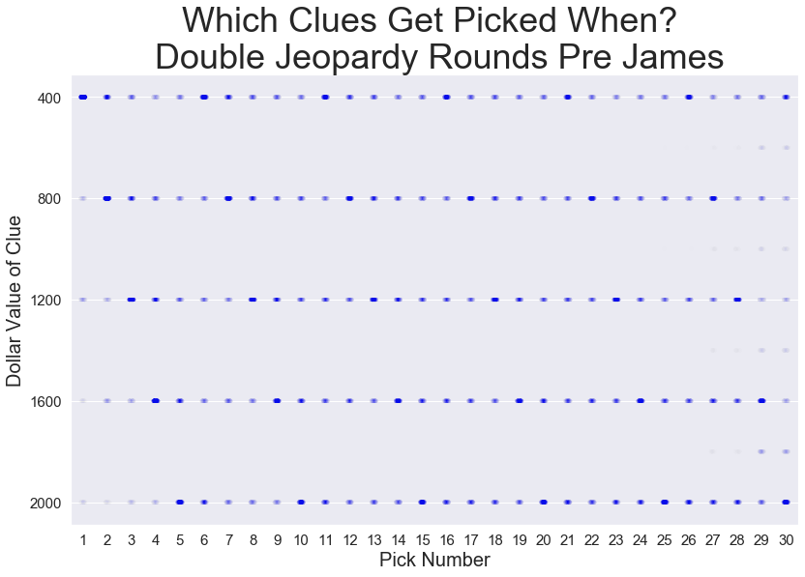

If you have to squint to see the pattern, you won’t have to when we look at the James Holzhauer games and witness his strategy writ large:

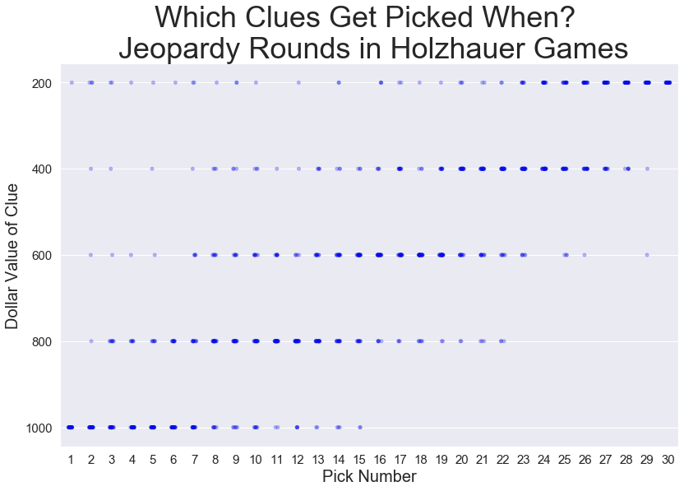

(You’ll notice that there aren’t any faint in-between dots on the right of this graph. That’s because, over the course of James Holzhauer’s 33 games, there was *not one clue* left unrevealed at the end of any round.)

Similarly with the Double Jeopardy Round, where two deviations seem visible. One is the first clue selection, where some of James’ challengers insisted on selecting from the top row. The other difference between the two rounds is the love shared more equally between the lower three rows―the result of Daily Double hunting. *Jeopardy!* fans know that, while the lowest row has a higher clue value, [rows three and four are favorites for harboring those key Daily Doubles](https://fivethirtyeight.com/wp-content/uploads/2019/04/roeder-jeopardy-3.png?w=575). Since contestants enter the second round with the money they won in the first, James already had the bankroll to finance enormous wagers and could start hunting for the Daily Doubles immediately.

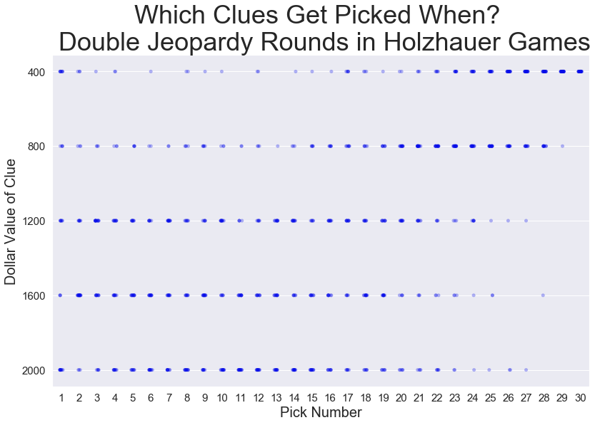

Now, in the next graph we’ll see how this season’s post-Holzhauer players are selecting clues. It’s harder to make out a pattern, precisely because, as we caught hints of previously, people aren’t sticking to one strategy any more. But do note one distinct phenomenon―the dark blue of the upper right corner, representing all the top row, low-value clues that contestants are leaving for the end.

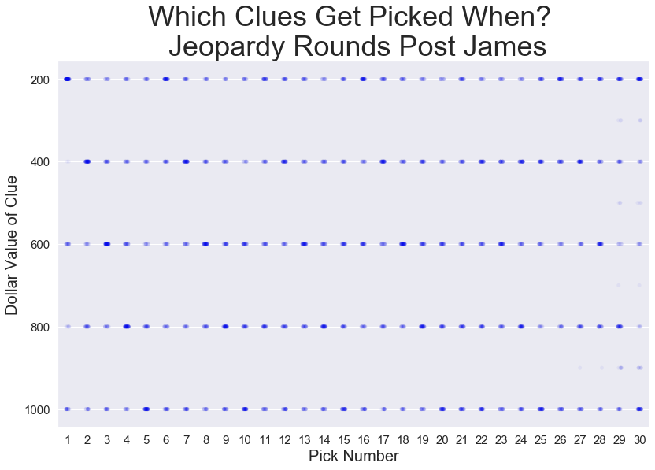

The emulation is real. And contestants don’t seem to care about disguising their admiration of “the man who solved *Jeopardy!*”, either. During a College Championship game on April 8, one contestant found a Daily Double and wagered “all in,” complete with the hand motion James used to evoke poker chips―to say nothing of the great Ken Jennings doing the same during January’s “Greatest Of All Time” tournament.

**Can everyone play like James Holzhauer--even when they aren’t James Holzhauer?**

In which case, the natural question seems to be: why isn’t *everyone* playing like James Holzhauer? If some people are diving for higher-valued clues sooner, why aren’t they all adopting this new dominant strategy?

It reminds me of *Avengers: Infinity War*, when Peter Quill (“Starlord”) asks Thor why only Thor is getting a “Thanos-killing” kind of weapon, and their whole crew can’t. Thor responds: “You simply lack the strength to wield them. Your bodies would crumble as your minds collapsed into madness.”

This application was clear to players when it came to James’ strategy in Daily Double wagering. Holzhauer could risk thousands of dollars because he could also correctly respond to [71 of the 75](https://fivethirtyeight.com/features/james-holzhauer-broke-jeopardy-but-is-broken-so-bad/) Daily Doubles he found during his run (94.7%). Contestants answering Daily Doubles this season are 278 for 439―or, enjoying a little worse than ⅔ accuracy (63.3%).

But maybe it also applies to clue selection. The five years prior to James saw contestants eventually (i.e., after perhaps an incorrect guess or two from an opponent) respond correctly to the game’s first clue 94.5% of the time. That was when they were picking the easiest clues. During James’ run, when he was selecting the board’s hardest material, the first clue still got answered correctly 90.9% of the time (mostly by James).

These days, when people dive for the $1,000 clues first, they are answered correctly just 73.9% of the time. That is slightly *worse* than the recent historical [by which I mean the past five years pre-James] average for $1,000 clues in the Jeopardy Round, which used to be answered right 78.9% of the time―an outgrowth, perhaps, of how playing through a category in clues of escalating difficulty can really be helpful, to the field as a whole if not to any one player.

Perhaps this is why it’s been rare to see a genuine commitment to (or perhaps, successful execution of) James’ strategy. Above, we saw that in James’ run $1,000 clues were almost always picked first and second in the Jeopardy Round; this season, though people are going for them sooner and more often, only seven games have begun with back-to-back $1,000 clues―and six of them were part of Jason Zuffranieri’s 20-game run.

Interestingly, when $2,000 clues are picked first in the *Double* Jeopardy Round these days, they are answered correctly 91.7% of the time, slightly better than the ultimate correct response rate (87.9%) of all first-picked Double Jeopardy clues during James’ run (still slightly below the historical average of first-picks of all values in the second round, though, which is 92.9%). Perhaps this is because of the lagging players getting to select them: someone behind might cherry pick an expensive clue from a promising category, while the clues selected first during a James game could come from anywhere. It’s especially likely they’re cherry-picking since, these days, top-dollar picks begin the second round only half as often as they begin the first round―suggesting that perhaps returning champs have some propensity to try Holzhauer’s strategy and pick anything high-valued, while contestants in third place are more sensitive to the categories present. Or maybe the people who win games are just more likely to be playing more rigorous strategies.

It will be exciting to see if future *Jeopardy!* seasons continue an inexorable drift in the direction of Holzhauer’s strategy, or if we’ve already arrived at the new normal, where one breed of contestant attempts to wield James’ gauntlet, while another, more numerous but perhaps less successful, opts for down-the-board play.

It wouldn’t be the first time that a technique is pioneered to much attention but then fails to redefine the game. Then-law student Chuck Forrest pioneered the “Forrest bounce” in the 1980’s, a strategy of bouncing unpredictably from one category to the next as a means of keeping your opponents off their feet. In 2014, Arthur Chu played similarly, but with an angle zeroed in on unearthing “those game-changing Daily Doubles,” [as Ken Jennings once wrote about it](https://slate.com/culture/2014/02/ken-jennings-on-jeopardy-champion-arthur-chu-and-daily-double-hunting.html). Then again, Holzhauer’s strategy has already evinced more staying power―not to mention more overt pastiches by college contestants―then either of those greats ever had.